**Appendix 5**. Intra-annual analysis of our species-area relationships for cities, random polygon patches, and the comparison between the two.

**Table A1**. Results from GAMs for the species-area relationship within cities, split intra-annually. Note that only a subset of the 1,581 cities were included in each model.

|  |  |  |  |  |  |  |  |
| --- | --- | --- | --- | --- | --- | --- | --- |
| Term | Season | Estimate | Std. Error | z value | Pr(>|z|) | Deviance explained | Number of cities |
| Patch area (log) | Summer | 0.178 | 0.001 | 199.592 | < 0.001 | 0.671 | 848 |
| Patch area (log) | Winter | 0.185 | 0.001 | 213.124 | < 0.001 | 0.820 | 1008 |
| Patch area (log) | Spring | 0.163 | 0.001 | 238.257 | < 0.001 | 0.644 | 1083 |
| Patch area (log) | Autumn | 0.194 | 0.001 | 242.316 | < 0.001 | 0.695 | 899 |

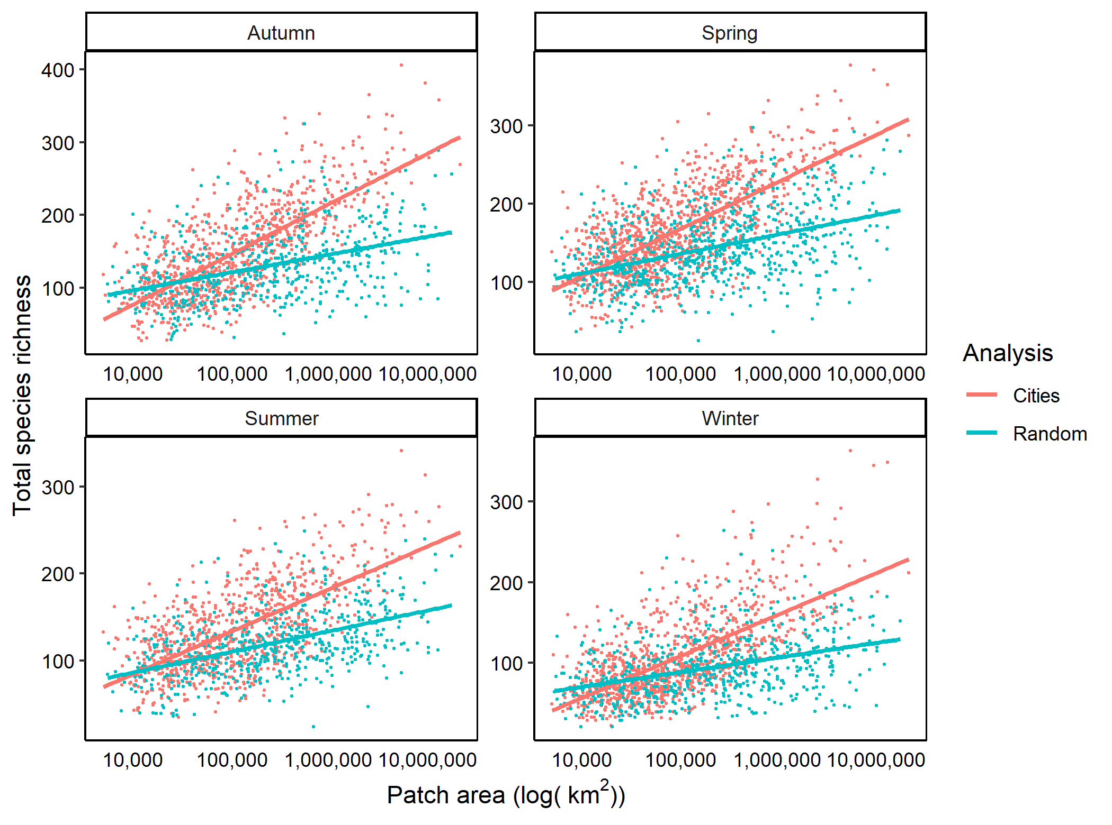

**Figure A1**. Species richness patterns per patch area, broken down intra-annually. For cities, the sample sizes were as follows: Summer – 848; Spring – 1083; Autumn – 899; Winter – 1008. For random polygons, the sample sizes were as follows: Summer – 563; Spring – 769; Autumn – 537; Winter – 620. See Table A2 for model results.

**Table A2**. Results of GAMs which tested for the interaction between analysis and patch area (bolded in the table below), separately for each season (N=4 models). The deviance explained ranged from 56% to 75%. Sample sizes for each of the analysis types per season are given in Figure A1 legend, above.

|  |  |  |  |  |  |  |
| --- | --- | --- | --- | --- | --- | --- |
| Term | Season | Estimate | Std. Error | z value | Pr(>|z|) | Deviance explained |
| Patch area (log) | Summer | 0.171 | 0.001 | 202.795 | < 0.001 | 0.590 |
| Random analysis | Summer | 0.853 | 0.025 | 34.036 | < 0.001 | 0.590 |
| **Patch area (log):Random analysis** | **Summer** | **-0.059** | **0.001** | **-44.244** | **< 0.001** | **0.590** |
| Patch area (log) | Winter | 0.177 | 0.001 | 214.254 | < 0.001 | 0.749 |
| Random analysis | Winter | 0.601 | 0.016 | 37.648 | < 0.001 | 0.749 |
| **Patch area (log):Random analysis** | **Winter** | **-0.073** | **0.001** | **-53.930** | **< 0.001** | **0.749** |
| Patch area (log) | Spring | 0.157 | 0.001 | 239.633 | < 0.001 | 0.560 |
| Random analysis | Spring | 0.433 | 0.012 | 36.223 | < 0.001 | 0.560 |
| **Patch area (log):Random analysis** | **Spring** | **-0.058** | **0.001** | **-56.738** | **< 0.001** | **0.560** |
| Patch area (log) | Autumn | 0.186 | 0.001 | 243.093 | < 0.001 | 0.606 |
| Random analysis | Autumn | 0.688 | 0.015 | 45.789 | < 0.001 | 0.606 |
| **Patch area (log):Random analysis** | **Autumn** | **-0.080** | **0.001** | **-63.053** | **< 0.001** | **0.606** |